**WEEK – 3 Assignments**

**Entity Framework Core 8. 0**

**Mandatory hands-on :-**

**Lab 1: Understanding ORM with a Retail Inventory System**

**Objectives :-**

Understand what ORM is and how EF Core helps bridge the gap between C# objects and relational tables.

1. **What is ORM?**

ORM (Object-Relational Mapping) is a technique that lets you interact with a database using C# classes instead of writing SQL queries directly.

Benefits:

* + Productivity: Write less code and focus on business logic, not SQL.
  + Maintainability: Changes in your C# code are easier to manage than raw SQL scripts.
  + Abstraction: You don’t need to know SQL to work with the database.

2. **EF Core vs EF Framework :**

EF Core

* Cross-platform: Works on Windows, Linux, and macOS.
* Lightweight: Designed for performance and efficiency.
* Modern features: Supports LINQ, async/await, compiled queries, bulk operations, and JSON columns.
* Flexible: Works with many databases (SQL Server, SQLite, PostgreSQL, MySQL, and more).
* Actively developed: Receives frequent updates and new features.
* Best for: New projects, cloud apps, microservices, and cross-platform solutions.

## EF Framework (EF6)

* Windows-only: Runs only on the .NET Framework.
* Heavier: More monolithic and less optimized for modern workloads.
* Fewer features: Limited async support, no compiled queries, fewer extensibility points.
* Less flexible: Mainly supports traditional SQL databases.
* Mature and stable: Well-tested and reliable for legacy applications.
* Visual designer: Includes EDMX for database modeling (not in EF Core).
* Best for: Maintaining existing Windows applications or when EDMX is required.

3. **EF Core 8.0 Features:**

* JSON column mapping: Store and query JSON data directly in SQL Server columns.
* Compiled models: Faster startup and query performance.
* Interceptors: Hook into database operations for logging or custom logic.
* Bulk operations: Improved support for inserting/updating many records at once.

4. **Create a .NET Console App :**

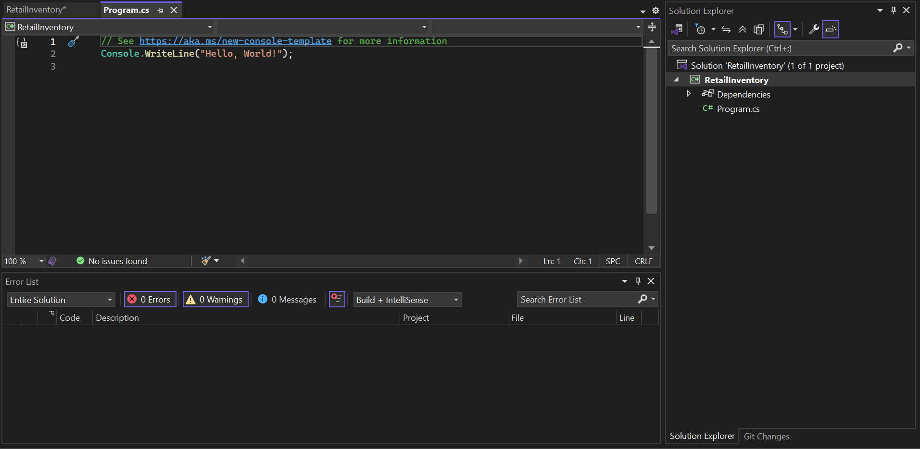

**5. Install EF Core Packages:**

* dotnet add package Microsoft.EntityFrameworkCore.SqlServer

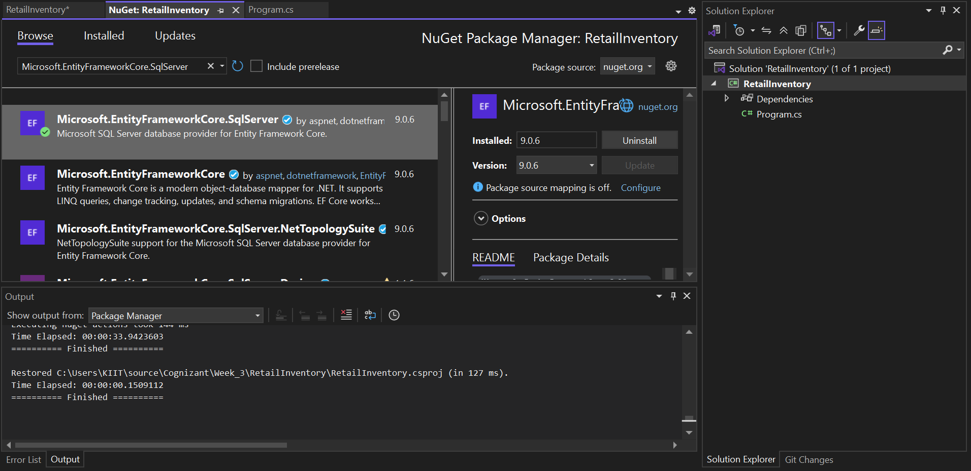

* dotnet add package Microsoft.EntityFrameworkCore.Design